Homes for Scotland Awards 2013

Best Employer Sponsored by Morton Fraser Solicitors

Winner:  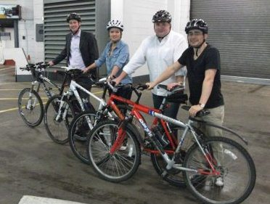 | Mactaggart & Mickel Group for its investment in people.  The judges were unanimously impressed with Mactaggart & Mickel’s commitment to personal development with a high number of training days, impressive use of staff forums and consequently improved employer/employee relations.  Further examples of innovation and competitive edge included a wind-down period for retiring employees, the use of staff surveys with thorough follow-up and the enhanced Corporate Social Responsibility approach encompassing, amongst other initiatives, the cycle to work scheme.
Young Achiever Sponsored by Clancy Docwra
Winner:   | Maureen Douglas – Forster Roofing  Among her many successes, Maureen has transformed health and safety practice within Forster Roofing, initiated and implemented quality assurance schemes and contributed at national level within her sector to promote the skills and training agenda through her contribution to industry-wide training and accreditation schemes.
Outstanding Achievement Sponsored by Anderson Strathern

Winner:  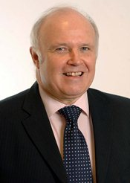 | Ronnie Jacobs  With a new build career spanning more than 30 years which includes positions at the highest levels with some of the UK’s largest builders, Ronnie has enjoyed a very distinguished career, playing a pivotal role in helping to further the interests of the home building industry.  He has been involved with a number of key organisations and committees, representing the industry’s views with the CBI and NHBC as well as the Scottish Government’s Housing Supply Task Force.

Best Marketing Campaign Sponsored by Dunedin Canmore Property Management

Winner:  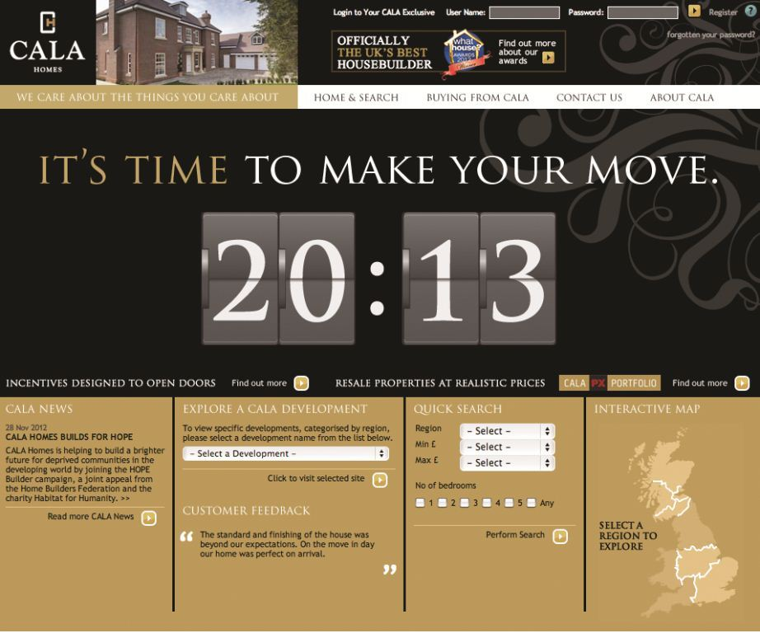 | CALA Homes for its “The Time is Now” campaign.  The winner without doubt in the judges’ view, CALA stood out by embracing multiple media channels, whilst shifting to a more ‘digital world’ on the back of the organisation’s own review of media effectiveness.  Whilst TV was used in the campaign, it was backed by a video on demand service, prompted on YouTube and linked via Facebook and Twitter platforms.
Commended:   | Cruden Homes West for the Park View First Time Buyer campaign.  The judges were impressed with the way in which Cruden Homes West built upon previous campaigns to concentrate on the key issues currently facing First Time Buyers; an approach which struck a chord with prospective customers as demonstrated by a significant uptake in sales.  Using real First Time Buyers meant that people were positioned firmly at the heart of the campaign, highlighting that purchasing a new home can be both achievable and affordable.
Best Green Initiative Sponsored by Ground Developments

Winner:  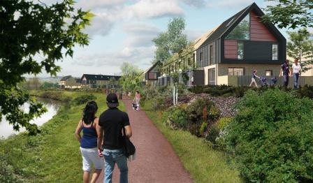 | Mactaggart & Mickel Group with CCG and Cruden Homes for the Athlete’s Village in the East End of Glasgow.  Adopting a joined-up, fabric-first approach saw the project stand out as a worthy winner in the judges’ view.  Transforming into a lively residential community with 700 homes, amenities and public spaces after the Commonwealth Games, the Village will have a host of innovative features.  The Village also demonstrates a commitment to waste and water minimisation with impressive porous surfacing allowing water to soak through to the natural water table.

Commended:  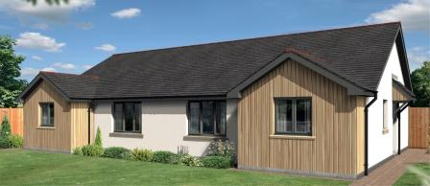 | Springfield Properties for its collaborative approach to developing a 2016 compliant, commercially viable home building system.  The judges commended the ambition which was demonstrated in this submission, with the overall commitment to delivering Gold standard homes well ahead of regulation clearly set out at all stages of the process.  Springfield demonstrated a highly efficient manufacturing process and use of materials, with scope for the system to be rolled out commercially, producing economies of scale which will reduce costs further.
Commended:  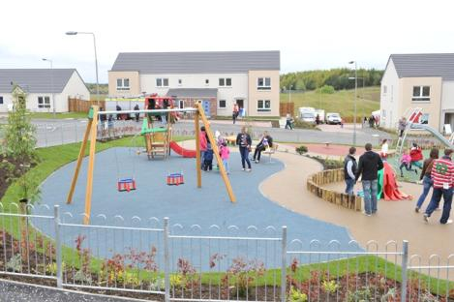 | Housing Innovation Showcase as submitted by Kingdom Housing Association.  Kingdom worked with a number of different companies to develop 27 new homes using 10 different modern methods of construction and various new technologies.  This uniquely innovative project showcases an industry-led approach to the delivery of affordable homes. With lessons that are likely to benefit the entire industry, the efforts by Kingdom are to be applauded.
Best Home Design Sponsored by Gillespie Macandrew

Winner:  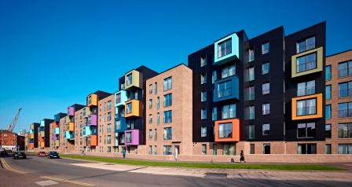 | Cruden Homes West for its Park View development in Govan.  The judges were unanimous in finding Cruden’s development of 42 high quality, contemporary and spacious two bedroom en-suite apartments worthy of the accolade of Best Home Design.  The tenement block is designed to follow the Glasgow tradition adapted effectively to suit modern living. It responds to its local identity, suitable in scale and provision to its suburban location and limited parking, providing drying greens that double as observable play areas. The colourful pods also add distinction and modernity.

Best Development – large (30+ units) Sponsored by NHBC

Winner:  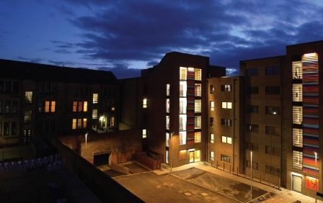 | Cruden Homes West for Park View in Govan.  In addition to the judges’ comments under the Best Home Design category, the Park View development was hailed for being both thoughtful and imaginative, spot on to the brief of meeting the needs of social housing and first time buyers, and an excellent address to the provision of housing in a challenging area.
Best Development – small (up to 29 units) Sponsored by Ross & Liddell

Winner:  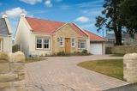 | Headon Developments for The Green at Strathkinness in Fife.  This development drew an array of favourable comments including attention to local characteristics, careful consideration of material and scale, genuine effort on local consultation and the substantial level of effort made.  Other features which the judges praised were the judicious blend with existing streets and buildings in the centre of the village, with open space providing linkage with the school, church and village hall.  Overall, this development was showcased within a quality submission which scored for its sensitive and inclusive approach.
Commended:  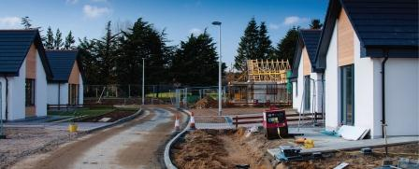 | Springfield Properties for its development at Duncanshill, Elgin.  Demonstrating accessibility and a flexible approach, the judges were impressed by this development’s response to local demand and context which is in keeping with existing nearby local housing stock.  The different house types display high levels of insulation and air tightness, and are built to take advantage of south-facing aspects.

Best Partnership in Planning Sponsored by Burness Paull & Williamsons

Winner:  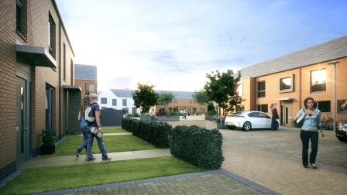 | Places for People with East Dunbartonshire Council for the Coal Board site at Twechar, East Dunbartonshire.  With “place making” a cornerstone of the Scottish Government’s current Planning and Architectural policies, the judges felt that this submission demonstrated that by placing this at the heart of the partnership it allowed the traditional barriers which exist between professions and sectors to be removed.  At the same time, the commitment to partnership working allowed the local community to play a positive and proactive role in delivering a scheme into their area which also generated a wider understanding and confidence in the planning process.
Best Partnership in Affordable Housing Delivery Sponsored by Forster Energy Solutions

Winner:  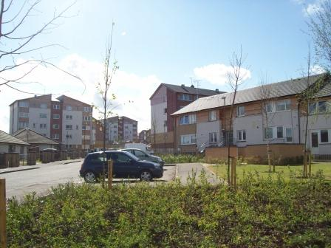 | Dunedin Canmore Housing with City of Edinburgh Council, Hart Builders and Lovell Partnerships for the large-scale regeneration project in the Moredun and Hyvots areas of South Edinburgh.  The project has resulted in the creation of 441 new homes and the refurbishment of 371 existing homes over several years, all at affordable rents.  This entry demonstrated real evidence of place-making, community participation and regeneration, including the establishment of residents associations, the provision of new community services, the promotion of youth activity and volunteering, training opportunities and the direct employment of 18 new apprentices.
Commended:   | West Lothian Council with Lovell Partnerships for the ambitious programme of 545 new council houses over eight sites.  With a total project value of £45 million, the new homes have been designed and built to a very high standard while making a key contribution to meeting housing need in the West Lothian area.  The project has delivered an estimated 74 job opportunities, the majority of which have been filled by local people.

Best Supporting Company Sponsored by Savills

Winner:   | PPS Scotland  PPS Scotland’s strong political and planning knowledge has been used to great effect in over half a billion pounds’ worth of housing projects.  The company’s success may well be the result of engaging not only with the client and the press, but also through positive consultation with local communities, an area which this submission pays particular credit to.  The judges were impressed with the level of professionalism displayed in this entry, with strong testimonials backing up the company’s approach to maintaining high standards and a focus on teamwork as being at the core of their values.
Commended:   | Gillespie Macandrew  The judges praised Gillespie Macandrew for the way in which it demonstrated not only its growing client base and commitment to supporting the home building industry, but also its increasing expertise in political lobbying.  Of particular mention, especially in this tough economic climate, are the capped fees and regular client performance reports which would undoubtedly prove of value and add an air of certainty.
Homes for Scotland Home Builder of the Year
Electronic voting system sponsored by Media Scotland

Winner:  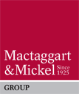 | Mactaggart & Mickel Group entered seven submissions with two going on to become category winners: the joined-up, “fabric-first” response to delivering 700 new homes at the Commonwealth Games’ Athletes’ Village took the award for Best Green Initiative and the demonstration of the organisation’s commitment not only to handcrafting quality homes but also to investing in its people saw it lauded as Best Employer.  Mactaggart & Mickel clearly demonstrated the scope of its expertise and commitment to effecting positive outcomes for the benefit of the home building industry as a whole across a broad range of areas.

