MEMBER ENGAGEMENT TOOLKIT

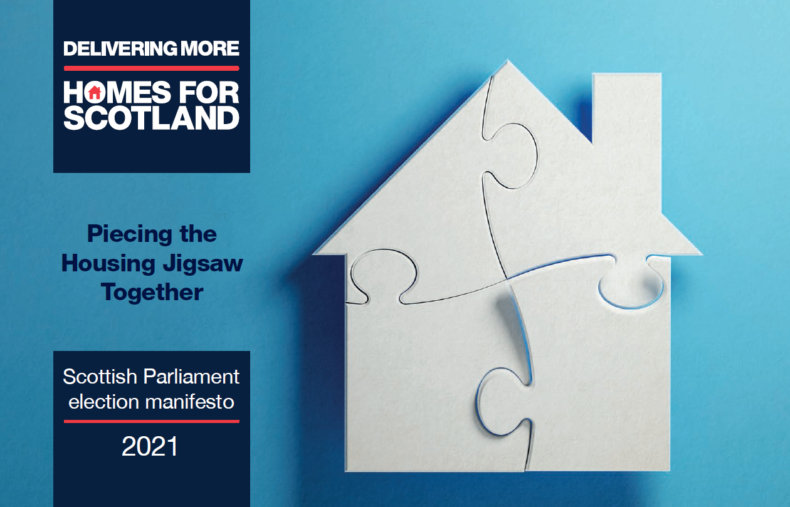

V2 as updated 16/04/21
CONTENTS

1. | Introduction | P1
2. | The Scottish Parliament Voting System | P2
3 | Template Letter/Email | P3
4 | Candidate Contact Details | P4
5. | Lobbying Register | P4
6. | Other Ways to Help | P5
7. | HFS Manifesto | P6
8. | Manifesto Talking Points | P7
9. | Easy-reference Benefits | P11
10. | Q&As | P12

1. INTRODUCTION

HFS needs your help to maximise our industry’s political engagement in the run up to the Scottish Parliament election on 6 May 2021.

Since publication of our manifesto in January, HFS has been undertaking significant engagement with key MSPs and party representatives on the overarching need for an annual all-tenure target of at least 25,000 new homes. We use a jigsaw analogy to highlight the myriad of inter-dependent elements that need to be brought together to achieve this.

With the Scottish Parliament now in election recess and campaigns underway, member assistance is required to amplify our messaging and strengthen industry connections at a local level. Members are urged to build on these relationships going forward - an exercise which will also prepare us well for next year's council elections.

Whilst HFS will be issuing a general emailer to candidates, we need you to reach out to those in your constituency area(s) to really make a positive case for home building across all tenures, particularly in terms of recovering from the impact of Covid-19.

To assist you with this, we have developed a special toolbox of resources which includes:

- a template letter/email
- candidate contact details
- manifesto talking points
- social media assets (pledge board, post calendar)

So that we can compile a comprehensive record of activity, please email details of your own organisation's efforts to Executive Team Assistant Vicki Craik.

Should you have any questions or suggestions for additional resources, please contact HFS Head of Public Affairs Jennifer Kennedy (j.kennedy@homesforscotland.com / 07763 240694).

2. THE SCOTTISH PARLIAMENT VOTING SYSTEM

At a Scottish Parliament election, each voter has two votes.

With one vote, voters choose between candidates standing in their constituency. There are 73 constituencies for Scottish Parliament elections. The candidates elected to represent constituencies are known as constituency MSPs.

The other vote is for a political party, or for a candidate standing as an independent, within a larger electoral area known as a region. There are eight Scottish Parliament regions and each region has seven additional seats in the Parliament. The candidates elected to these 56 additional seats are known as regional MSPs.

Each Scottish resident is therefore represented by eight MSPs: one constituency MSP and seven regional MSPs.

The voting system used in Scottish Parliament general elections is known as the Additional Member System (AMS). AMS is a type of proportional representation. This means that the share of seats each party receives broadly reflects its level of support among voters.

The MSPs for the constituency seats are elected using the first-past-the-post system whereas regional seats are calculated using a formula which takes into account the number of regional votes that a party has received and the number of constituency seats it has already won.

NB: As an apolitical organisation, HFS does not advise members on the merits of political parties or candidates. This is a matter for individuals.

3. TEMPLATE LETTER/EMAIL

The template below has been prepared to ensure consistency of messaging and should be adapted to suit individual member company circumstances. You are encouraged to write to both constituency and regional candidates (noting that a candidate can be both).

Dear [name]

As a home builder and investor [based/operating in your constituency, employing a total of xx people including xx office and xx site based staff], I am writing to you in your capacity as a candidate for the Scottish Parliament election on 6 May to impress upon you the vital role that home building has to play in [constituency name]’s social and economic recovery from Covid-19.

The past year has shone a very bright light on the importance of ensuring everyone living in Scotland has a quality home that meets their needs.

If we've learned anything it is that a home is so much more than simply bricks and mortar. It is a place of safety, shelter and security which contributes to our positive mental wellbeing as well as wider health and education outcomes. It is fundamental to the human right to an adequate standard of living.

Yet, across Scotland, we still don’t have enough homes to house all our citizens. This has got to change, which is why I am writing to seek your shared commitment to the delivery of much needed new housing of all tenures in your dealings with local stakeholders and if elected.

Housing delivery is a complex process, requiring the bringing together of a myriad of different elements, just as our representative body Homes for Scotland illustrates in its manifesto “Piecing the Housing Jigsaw Together”. Whilst national policy sets our ambition on housing, it is at a local level that this is executed. MSPs are therefore a crucial conduit to ensuring constituents have access to a range and choice of quality housing options, recognising and welcoming the wide-ranging benefits from new development that accrue such as local investment, regeneration, sustainability and employment.

Did you know that increasing access to high-quality, energy-efficient new homes:

- Tackles inequality by regenerating and sustaining communities, increasing opportunity and supporting aspiration
- Helps reduce fuel poverty
- Aids the fight against climate change
- Supports vital jobs and training
- Contributes to economic growth
- Triggers ongoing resident expenditure and increases public finances

I would welcome the opportunity to discuss in detail with you the action that is required to deliver more homes, particularly in assisting those who are unable to save large mortgage deposits given recent announcements on the First Home Fund and the main Help to Buy scheme, and would be happy to arrange a photo opportunity at our [site name] development which [site info eg comprises xx private and xx affordable homes for first time buyers and families] if that would be of interest.

I look forward to hearing from you.

Yours

4. CANDIDATE CONTACT DETAILS

Constituency and regional candidate contact details can be found here.
(NB: given the number of candidates, details have been restricted to the 5 main parties but these can be expanded using the filter option should you wish.)

To check your constituency and region by post code, click here.

Please note:

- Unfortunately, some candidates don’t agree to share their contact details.

- The sheet is sorted by constituency and region but can also be filtered by surname and party.

- Region: The region column is completed for all candidates to enable filtering by region (constituency + list), but it is greyed out for Constituency Only candidates to make it more obvious where they’re standing but enabling the list to be sorted by region, where that’s useful.

- There are 459 candidates across the five current ScotParl parties (constituency & list) – we have email addresses for 361.

- Though @parliament.scot addresses aren’t being checked, some elected councillors and MPs are continuing to check their elected member emails, so these are still alternative points of contact if the campaign email cell is blank.

5. LOBBYING ACT
Normally, during a Scottish Parliament Election, an MSP's term of office ends with the dissolution of the Parliament (Scottish Ministers, the Permanent Secretary and retained special advisers continue to hold office during the election period).
However, due to Covid-19, instead of dissolution, Parliament has entered a period of recess instead in case it needs to be recalled. As such, any face-to-face (in person or via video call) regulated lobbying engagement with any MSP in relation to Government or parliamentary functions during the recess period would continue to be a registrable activity.
Guidance on regulated lobbying can be found here.

6. OTHER WAYS TO HELP

In addition to our correspondence campaign, you could also:

- Organise your own online/virtual debates and discussions
- Participate in local debates and ask questions
- Write blogs and opinion pieces for local media
- Invite candidates for photo opportunities (subject to health and safety requirements)
- Share our Twitter and LinkedIn posts
- Use our pledge boards and share on social media / tag local candidates to do the same

Pledge board examples (download here)

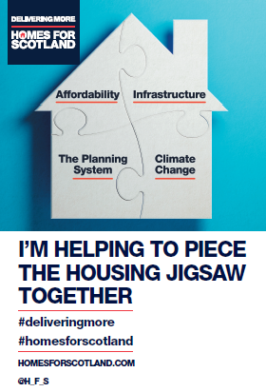 |  |  | 
Animated GIFs (download here)

7. HFS MANIFESTO: Piecing the Housing Jigsaw Together

The importance of ensuring everyone living in Scotland has a quality home that meets their needs has never been more apparent. Our manifesto therefore calls for politicians across all parties to support a shared ambition to achieve and consistently deliver at least 25,000 new homes of all tenures each year.

As members are keenly aware, the process of delivering much-needed housing is extremely complex and challenging. Our manifesto recognises this and draws attention to the myriad of different elements that need to be brought together. Using the analogy of a jigsaw puzzle, the premise is very simple: no piece can be missing if Scotland’s housing objectives are to be achieved.

The manifesto emphasises that housing is fundamental to the desires for inclusive growth and the human right to “an adequate standard of living”. It also states that new housing delivery must lie at the heart of Scotland’s post-Covid recovery, stressing the vital economic and social impact it delivers. It further underscores the interdependency between public and private sectors.

Key messages:

- Delivering at least 25,000 new homes each year of the next parliament is achieved, this would generate +£25bn GVA  - Every new home built supports 4 jobs  - Every £1m output spent results in £2m GVA across the Scottish economy | - Increasing the stock of energy-efficient homes will help to:  - reduce fuel poverty  - tackle inequality  - regenerate and sustain local communities  - improve opportunity and support aspiration

Our calls are centred around the need for:

- An unequivocal need to achieve and consistently deliver at least 25,000 new homes of all tenures each year  - Support for consumer and business confidence  - A deliverable housing vision including increased investment in local authority planning and consenting services  - Alignment of national and local policy |  | - Leadership towards green transition  - Support for SME builders  - A national delivery agency  - A planning system focused on delivering quality homes (at least 25,000 a year) and places  - Up-front strategic infrastructure delivery  - Promotion of low carbon housing  - Specific measures to support Affordable Housing
Online manifesto | Print manifesto |  | Manifesto video

8. MANIFESTO TALKING POINTS:

- A shared and unequivocal ambition to achieve and consistently deliver at least 25,000 new homes each year (worth +£25 billion GVA over the next term of the Scottish Parliament)

Setting an aspirational annual target of at least 25,000 new homes to be delivered across all tenures would add substance to political rhetoric about the importance of housing in the round and reaffirm to developers across the spectrum that they are valued contributors to social and economic recovery.

Above all else, however, it would focus minds and efforts at all levels of government and provide an impetus to ensure homes are delivered at the volume required to effectively tackle what has been a consistent undersupply across the board.

(b) Support for consumer and business confidence

A clear statement of intent on housing delivery will provide the certainty that is required to encourage private sector investment.

With home ownership remaining the clear tenure of choice for the majority of households, such aspiration (particularly for younger people and the squeezed middle) must continue to be supported through initiatives such as Help to Buy and the First Home Fund to provide greater opportunity and help relieve pressure on the social sector at a time when public funds will be severely constrained.

LBTT should be reviewed in the context of disparity elsewhere in the UK and support extended for home movers as well as First Time Buyers to avoid any market blockages.

- A deliverable housing vision
Expectations on housing delivery must be rooted in reality, the barriers which hamper it addressed and commercial viability recognised. A crucial element of this is ensuring that local authorities receive the investment that they need to support delivery.

Local authorities need to be properly resourced so they can deliver the plans, permissions and consents that are a pre-requisite for housing development. Planning services can’t be funded through applicant fees alone if they are to deliver the wide range of outcomes places on planner’s shoulders.

- Leadership towards green transition

The direction of travel is clear and our trade body Homes for Scotland has undertaken work to develop a realistic industry route map and will share this work later in the year. It is nevertheless important to recognise how far the home building industry has already come over the past decade.
Further enhancements will need to be carefully balanced against cost and viability concerns, with support for the mainstreaming of and investment in new technologies/materials and decarbonisation of energy infrastructure also required.

In addition, there must be consistency around policy across national and local government with Building Standards remaining the prime channel for delivering sustainable buildings.

- Support for SME home builders

During the course of 2019, HFS worked with members and the Scottish Government to produce an action plan to support the SME home builder sector in Scotland which had never fully recovered from the 2008 recession. With that position now exacerbated by the pandemic, and in order to increase housing capacity and diversity, we ask now that the next Scottish Government, local authorities and other agencies commit to proactively working with industry to implement the key recommendations of that work which include:

- addressing access to development finance (eg we propose extending the successful emergency liquidity fund to support short and medium term development)
- the waiving of developer contributions on sites up to 12 homes
- a focused development management approach
- removing the physical and financial barriers that directly penalise smaller builders

- A national delivery agency

Scotland does not have a single body responsible for ensuring enough new homes are delivered. No-one is held to account in a meaningful way.

Reflecting on the success of the New Town Development Corporations of the past, a national housing delivery agency could work with local authorities to make sure enough land is available for new housing across Scotland, avoiding the need for protracted discussions with industry and costly appeals.

We propose responsibilities also include:

- securing, masterplanning and preparing public sector surplus land ready for development
- providing and managing financial packages of support
- delivering infrastructure
- promoting innovative solutions

- A planning system focused on delivering quality homes and places

It is absolutely essential that NPF4 provides clear and ambitious housing targets to focus local authorities and agencies on delivery so we are particularly concerned by the confusingly low “initial default estimate” figures generated by the Scottish Government which, if adopted, would see Scotland planning for 37 per cent fewer homes each year than the 22,596 built in 2019.

Underestimating need and demand would restrict the supply of land available and restrict the industry’s ability to play its full part in contributing to economic and social recovery.

- Up-front strategic infrastructure delivery

Infrastructure funding and delivery is one of the biggest blockers to the delivery of new homes and can make it harder for existing communities to welcome new development.

Problems arise when the cost of the infrastructure needed to support development is very high (eg expensive one-off items such as secondary schools or the cumulative impact of several smaller items such as primary schools, waste water treatment works or roundabouts).

The nature of land allocations over the last ten years has seen a greater reliance on larger strategic sites of over 500 homes, which require more significant infrastructure investment. The lack of a common “infrastructure-first” approach to forward-funding these strategic developments has been a huge problem and has a major impact on the industry’s ability to provide the homes that have been allocated in plans and for which there is a clear need.

We therefore welcome the Infrastructure Commission’s recommendations which should be actioned to ensure a joined-up approach to delivery of
national, regional and local infrastructure. There is also a key role for the
Scottish National Investment Bank to deliver essential low-carbon
infrastructure.

- Promotion of low carbon housing

The green transition will be challenging for both industry and customers. It is clear that the Scottish Government must intervene to make these choices
more attractive than they currently are, embedding zero carbon as a primary consideration in the delivery of new homes, creation of place and the growth of resilient communities. In addition, the Scottish Government must encourage and support the wider supply chain if this transition is to be delivered.

In particular, we propose:

- a public information campaign highlighting the benefits of new low-carbon
technologies
- linking LBTT and council tax to energy-efficiency to accelerate consumer/public culture change
- working with lenders and surveyors to establish refreshed valuation methodology that reflects the costs and benefits of new technologies

- Specific measures to support Affordable Housing

Homes for Scotland promotes an all-tenure approach, viewing the housing system as a whole to provide those living in Scotland with the range and choice of quality housing options they require during their own housing journeys.

With interdependencies across sectors, private developers and RSLs work closely together to create mixed tenure communities, with grant funding often a catalyst for the opening up of sites that may have significant upfront infrastructure costs.

It is therefore essential that current levels of grant support and investment are continued in the next Parliament, taking into account additional carbon reduction-related costs.

Further, efficiencies in procurement and design can be improved to maximise the benefit of public sector funding and innovative financial models created to leverage private investment.

It is also important that the broad definition of affordable housing as set out in Scottish Planning Policy* is retained in NPF4 and applied directly to all parts of Scotland.

*Housing of a reasonable quality that is affordable to people on modest incomes. May be provided in the form of social rented accommodation, mid-market rented accommodation, shared ownership housing, shared equity housing, housing sold at a discount (including plots for self-build), and low cost housing without subsidy.

- Alignment of national and local policy

Whilst the need for new homes is recognised by national politicians, this often does not translate at a more local level. MSPs therefore have an important conduit role to play in bridging the void that too often exists so that those living in their constituencies can access the new homes they genuinely need - and aspire to.

All portfolio areas and strands of government need to be aligned to improve the
efficiency of housing delivery, with clear and consistent language in national policies and local authorities incentivised to deliver. Housing delivery must be embedded as a golden thread in all decision-making.

For planning reform to achieve its intended aim of delivering more homes, it will need to be supplemented by reform of all other consent regimes and regulatory organisations to align with that aim eg building warrant and roads construction consent delivered to support rather than compete with planning decisions.

In particular, there needs to be consistency around low carbon policy with national targets met through Building Standards which must remain the prime channel for delivering sustainable buildings to avoid a situation whereby some authorities may seek to “out green” others.

9. EASY-REFERENCE BENEFITS¹

As well as contributing to improved health and education outcomes, the Scottish home building industry generates significant economic benefits at both local and
national level.

The below highlights this on an annual basis per home, what was achieved in 2019 based on 22,596 completions and what could be gained if our minimum 25,000 all-tenure target was reached.

Measure | Per home² | Achieved in 2019³ | Uplift at 25,000
Jobs⁴ | 4 | 90,384 | 9,619
GVA⁵ | £205,000 | £4.6bn | £0.5bn
Local Spend Year 1⁶ | £5,000 | £113m | £12m
Council Tax⁷ | £990 | £22.4m | £2.4m
Section 75⁸ | £5,378 | £121.5m | £13m

GVA is 2013-based. All other measures are 2014-based. No adjustments have been made for inflation, Council Tax increases, s75 contribution policy increases or other circumstantial changes. Based on “The Economic & Social Value of Home Building in Scotland” report. HFS is in the process of updating these figures to reflect circumstances in 2021.
2 ‘Per Home’ figures based on 15,563 homes built in 2015 and the benefits our research shows they generated.
3 In 2019 Scotland built 22,596 homes of all tenures.
4 Each new home creates and supports 4.07 jobs. This has been rounded to 4 for these calculations.
5 Each new home generates £205,629 to GVA This has been rounded to £205,000 for these calculations.
6 Occupants spend on average £5,000 more in the local economy in the year they buy a new home.
7 Each new home contributes on average £990 a year in Council Tax.
8 Each new home generates on average £5378 in Section 75 Developer Contributions.

10. Additional resources

The below may also assist members with their discussions:

The Role of Home Building in Scotland’s Recovery

The Economic & Social Benefits of Home Building in Scotland report

About Homes for Scotland

Mythbusting

Why buy new?

